Bootstrap 5 Containers

Containers are used to pad the content inside of them, and there are two container classes available:

1. The .container class provides a responsive **fixed width container**
2. The .container-fluid class provides a **full width container**, spanning the entire width of the viewport



## **Fixed Container**

Use the .container class to create a responsive, fixed-width container.

Note that its width (max-width) will change on different screen sizes:

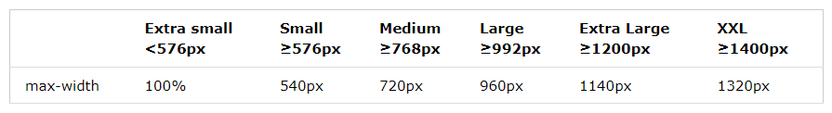

Open the example below and resize the browser window to see that the container width will change at different breakpoints:

### **Example**

<div class="container">  
  <h1>My First Bootstrap Page</h1>  
  <p>This is some text.</p>  
</div>

The XXL breakpoint (≥1400px) is **new** in Bootstrap 5, while the largest breakpoint in Bootstrap 4 is Extra large (≥1200px).

## **Fluid Container**

Use the .container-fluid class to create a full width container, that will always span the entire width of the screen (width is always 100%):

### **Example**

<div class="container-fluid">  
  <h1>My First Bootstrap Page</h1>  
  <p>This is some text.</p>  
</div>

To know [clickhere](https://www.w3schools.com/bootstrap5/bootstrap_containers.php)

References

https://www.w3schools.com/bootstrap5/bootstrap_containers.php